DUOFLAMINGO ANALYTICS PLATFORM

WEEK 2 - DATA MODELLING AND TRANSFORMATION STRATEGY
Project Domain: SaaS & Digital Subscription Analytics
Tool: Microsoft Power BI Desktop
Dataset: SaaS Subscriptions & Customer Churn Dataset (Version 1.0.0)
1. INTRODUCTION AND OBJECTIVES
DuoFlamingo Analytics Platform is a business intelligence project focused on analysing subscription-based business operations using Microsoft Power BI. The objective of this task is to transform raw subscription data into a structured reporting model through data preparation, relationship design and DAX calculations.
The key objectives are to:
- Import and inspect multiple CSV datasets.
- Design a relational data model and Entity Relationship Diagram (ERD).
- Perform data transformations using Power Query.
- Apply normalisation and denormalisation concepts.
- Develop DAX measures for revenue, subscriptions and payment analysis.
- Establish data quality checks and error-handling procedures.

2. DATASET OVERVIEW
The project uses the publicly available SaaS Subscriptions & Customer Churn Dataset, Version 1.0.0, published by Analytics Engineering.
Source: https://www.analyticsengineering.com/datasets/saas-subscriptions

2.1 Source Tables
Table | Records | Key Information
Accounts | 5,000 | Customer details
Plans | 4 | Subscription plans
Subscriptions | 5,000 | Subscription status and MRR
Invoices | 85,448 | Billing information
Payments | 87,287 | Payment attempts and status
Total | 182,739 | Five CSV files

3. DATA MODEL DESIGN
A relational data model was developed in Power BI by maintaining the five source tables separately and connecting them through their common identifiers.A calculated Date dimension (DimDate) was also created to support time-based analysis.

3.1 Relationships
Parent Table | Related Table | Key | Cardinality
Accounts | Subscriptions | account_id | 1:*
Plans | Subscriptions | plan_id | 1:*
Subscriptions | Invoices | subscription_id | 1:*
Invoices | Payments | invoice_id | 1:*
DimDate | Subscriptions | Date / started_at | 1:*
The relationships use single-direction filtering. The unique identifier is maintained on the one side and the corresponding foreign key on the many side.This structure supports customer, plan, subscription, revenue and payment analysis while preserving the original data organisation.

4. ENTITY RELATIONSHIP DIAGRAM (ERD)
The ERD represents the connections between the five business entities and the Date dimension.The model follows the subscription business process:
Accounts and Plans → Subscriptions → Invoices → Payments
The Date dimension is connected to the subscription start date to support calendar-based reporting.
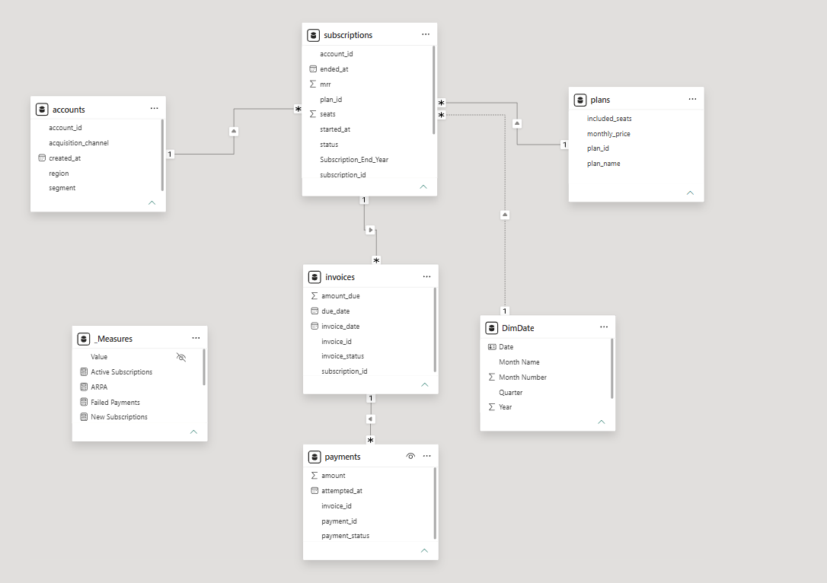
The model provides a structured foundation for analysing subscription activity, plan-wise revenue and payment performance.

5. NORMALISATION AND DENORMALISATION
The DuoFlamingo dataset follows a relational structure in which customer accounts, subscription plans, subscriptions, invoices and payments are maintained as separate entities.This approach reduces unnecessary duplication and maintains data consistency. For example, customer details are stored in the Accounts table and referenced through account_id in the Subscriptions table.
In Power BI, the related tables are connected through primary and foreign keys. Instead of physically combining all source files, relationships and DAX measures are used to generate reporting insights.This approach preserves the source structure while providing an integrated analytical view. It combines the benefits of normalised source data with the flexibility of reporting-oriented analysis.

6. POWER QUERY DATA TRANSFORMATION
Power Query was used to import, inspect and prepare the five CSV datasets before loading them into the Power BI model.The transformation workflow consisted of:
Stage | Activity
Data Import | Imported all five CSV files using Get Data → Text/CSV
Data Inspection | Reviewed column names, data types and categorical values
Duplicate Assessment | Checked primary identifier fields for duplicate values
Date Transformation | Created year, month, month-name and quarter attributes
Missing Value Handling | Preserved legitimate null values in ended_at
Data Loading | Loaded the prepared tables using Close & Apply
Additional date attributes were created in the Subscriptions table using Power Query custom columns.
For example:
Date.Year([started_at])
Date.MonthName([started_at])
"Q" & Text.From(Date.QuarterOfYear([started_at]))
A separate DimDate table was also created in Power BI using DAX to support calendar-based analysis. Its Month Name column was sorted using Month Number.The original source columns were retained to preserve the underlying information.

7. DAX FUNCTIONS AND MEASURES
DAX was used to develop analytical measures for subscription and payment performance. The following functions were applied:
Function | Application
SUM() | Revenue aggregation
DISTINCTCOUNT() | Unique account and subscription counts
COUNTROWS() | Payment attempt counting
CALCULATE() | Applying analytical filters
DIVIDE() | Safe division
YEAR(), MONTH() | Date extraction
FORMAT() | Date formatting

7.1 Key DAX Measures
Total MRR – Active Subscriptions
Total MRR =
CALCULATE(
SUM(Subscriptions[mrr]),
Subscriptions[status] = "active"
)
Active Subscriptions
Active Subscriptions =
CALCULATE(
DISTINCTCOUNT(Subscriptions[subscription_id]),
Subscriptions[status] = "active"
)
Total Accounts
Total Accounts =
DISTINCTCOUNT(Accounts[account_id])
Average Revenue Per Active Subscription
ARPA =
DIVIDE(
[Total MRR],
[Active Subscriptions],
0
)
Payment Success Rate
Payment Success Rate =
DIVIDE(
CALCULATE(
COUNTROWS(Payments),
Payments[payment_status] = "succeeded"
),
COUNTROWS(Payments),
0
)
Failed Payments
Failed Payments =
CALCULATE(
COUNTROWS(Payments),
Payments[payment_status] = "failed"
)
Total Payment Attempts
Total Payment Attempts =
COUNTROWS(Payments)

7.2 DAX Calculation Example
Assume active subscriptions generate a combined MRR of ₹2,250 across three subscriptions.
ARPA = Total MRR / Active Subscriptions
ARPA = ₹2,250 / 3
ARPA = ₹750
This is an illustrative example demonstrating the calculation logic, not an actual dataset result.The measures were organised in a dedicated _Measures table and tested using Card visuals and a Plan-wise MRR table.

8. DATA QUALITY ASSESSMENT AND ERROR HANDLING
Data quality checks were performed to assess the reliability and consistency of the imported datasets.

8.1 Quality Assessment Results
Check | Observation
Accounts primary identifier | No duplicates found
Plans primary identifier | No duplicates found
Subscriptions primary identifier | No duplicates found
Invoices primary identifier | No duplicates found
Payments invoice_id inspection | No duplicates returned
Subscription status | active, cancelled
Invoice status | open, paid, void
Payment status | succeeded, failed
Missing ended_at values | 4,035
The 4,035 missing values in ended_at were preserved because they can represent ongoing subscriptions. They were not automatically treated as errors.The Payments table contains 87,287 records, compared with 85,448 invoice records. Payment attempts must therefore be analysed separately from invoice amounts to avoid possible duplication when combining billing and payment data.

8.2 Proposed Error-Handling Strategy
Potential Issue | Recommended Action
Duplicate primary identifiers | Investigate and resolve duplicates
Missing mandatory identifiers | Identify and investigate incomplete records
Incorrect data types | Convert columns to appropriate types
Invalid date values | Inspect and correct source errors
Unmatched foreign keys | Identify orphan records
Unexpected status values | Investigate and standardise
Calculation inconsistencies | Validate DAX against source data
Legitimate null values | Preserve according to business rules
Power Query profiling, relationship validation and DAX testing provide a systematic approach to maintaining data quality.These checks help ensure that the information used for business intelligence reporting remains consistent and reliable.

